Technologies used to design Internet Monitoring System (MyCyberCafé)

Node.js
There is no doubt that JavaScript is a powerful language for many webapps, and the evidence is prevalent within research according to the Stack Overflow trends it is one of the most popular Languages in the world (<i>StackOverFlow</i>).

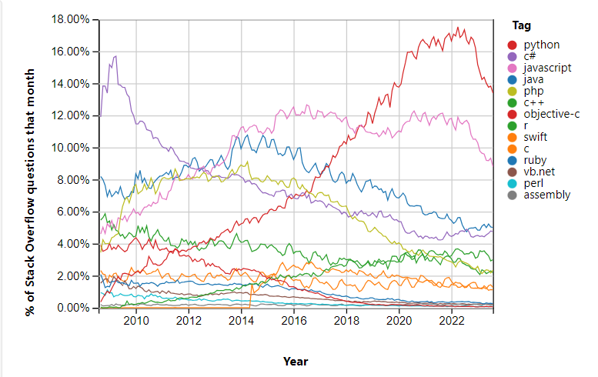
Figure 1 (Graph of most popular Languages according to stackoverflow)

As you can see from the graph above JavaScript is the most popularly talked languages in one of the most popular forum pages within stack overflow just behind python.
One of the things that make JavaScript so powerful is its support and libraries made by developers making it a relatively easy language to develop in. Another amazing aspect of JavaScript is its frameworks and one that will be prevalent in this project is node.js. node.js is very popular in server-side web development as its high performance and asynchronous meaning that it is not an interrupt driven i/0 (Tilkov and Vinoski, 2010). Node truly does simplify the concept of multithreading programming this is where a computer executes two or more concurrent programs this is very helpful for web developers as they deal with a lot of i/o whilst collecting and displaying user data (Tilkov and Vinoski, 2010).
Another aspect of node is the database connectivity compared to other web development languages such as PHP it is a lot easier to make database connectivity as it can be done in one file and can be called in to effect when needed such as login and sign-up for example.

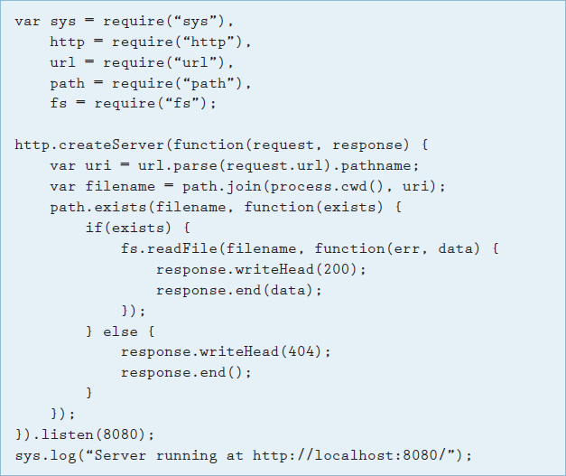
Figure 2 (A simple Database connectivity Script)

This is a familiar script to anyone who has built a database using node.js as a backend language (Tilkov and Vinoski, 2010). This is why node will be a huge part of our project its simplistic and easy to understand compared to other web languages.
Next.js
Next.js is another framework we will use on top of node.js it is a server-side framework that which worked together with node.js it organises files in a simple file format (Dinku, 2022).

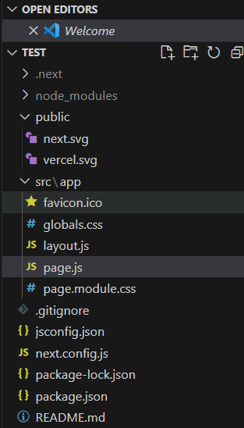
Figure 3- File layout for next.js

Upon building a simple application by installing node.js you can open the Terminal, PowerShell or Konsole depending on what operating system you use and enter in the simple command.

npx create-next-app@latest

This is truly impressive that anyone can do this with one command after entering this command is entered you are prompted with naming your project, using multiple technologies such as TypeScript and TailWind.css along with the option to use an app router.

The way routing works in Next.js is truly breath-taking. Routing is the way requests are made from the specified URL to the code that is handled. Routing in next.js follows three rules. Rule number 1 is the index routes (Child Route), so everything maps back to its parent’s routes e.g., ‘pages/index.js’ maps back to ‘/’. The second rule is that the router URL automatically detects nested folder structures, and the last rule is dynamic routing where the router uses a named parameter to match URLS (Dinku, 2022).

API routes can be used in next.js to create an API (Application Programming Interface). It is represented as a file in the ‘pages/api’ this is a server-side folder only and does not add to the size of the client-side folder (Dinku, 2022). To make an API route work it must first export a function to get request and response inputs via ‘POST’ like how it is done in PHP. This is essentially a request handler and is written in an if statement (Dinku, 2022).

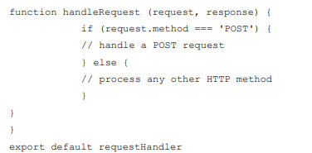
Figure 4- Request Handler

Databases
There is no doubt nearly any project or piece of software an individual develops requires a database but it’s about which database should be chosen? It is simplified into two types of databases a SQL and No SQL database where SQL is a relational database, and No SQL are non-relational databases. There are two types of databases being researched SQL and Mongo DB

SQL
SQL is a tool for organising, managing, and retrieving data stored by a computer database. SQL stands for structured query language (Groff<i> et al.</i>, 2002). The structure of SQL is very simple it has the database the database management system i.e., the actual computer system and the requests witch then gives back data. SQL uses queries to fetch and retrieve data from the database through the database management system.

SELECT CustomerName, City FROM Customers;
The above Query for example would allow the server admin or user to see all the customers names in the customers table.

SQL was originally built as an ad hoc query language which is extreme to think considering how much is capable with it now. SQL can now create databases, manage security, update, retrieve and share data. As a result of this companies all over the world use this tool for creating databases as its cheap globally used and the concepts are easy to learn (Groff<i> et al.</i>, 2002).
Relational Databases
As discussed, SQL is a relational database meaning that different data is related to one another each piece of data has an entity related to it and the relationships can be shown in a ERD (Entity Relationship Diagram) (Schema, 1995).

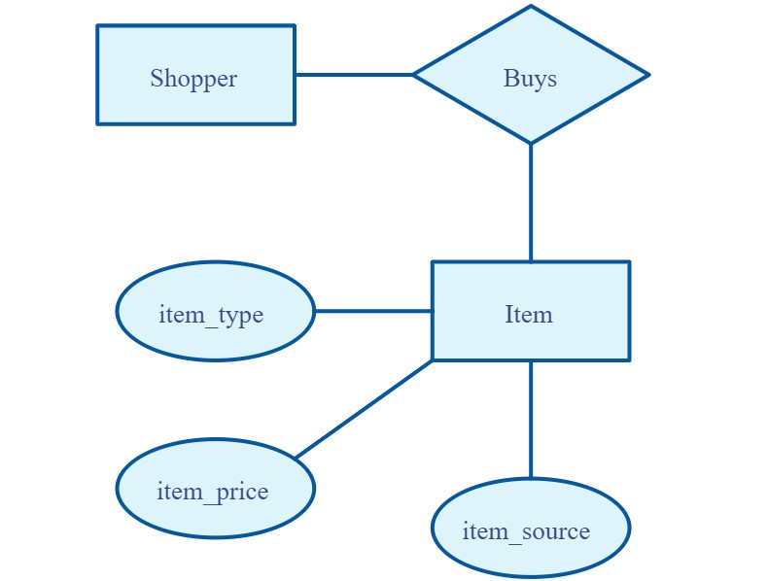
Figure 4- Example of an ERD Diagram

Each attribute also has a domain which is essentially an element that makes the data unique for example, INT is a domain that makes is so the data must be a positive whole number whilst a varchar(10) is a string of characters that are ten characters long (Schema, 1995). It is very important that all datatypes are accurate to their essential purpose e.g. if you were to do a collection at a GP and you needed to know if they had a medical card you wouldn’t use a VarChar(3) to write yes or no in as retrieving or holding that data can result in being very difficult in this case you would use a Boolean as its either a one or another situation and it would be represented as medicalCard(true/false).

With relational databases Aswell the design is so important, and a lot of issues can occur if the design and implementation phase goes wrong such as Unnecessary Duplicated data and Consistency for example in the book Relational Database Design and Implementation by Jan L.Harrington he uses the example of Antique Optical a book/DVD store that created a database witch worked well for a while but as the business expanded data was drastically duplicated. This was due to the simple fact that every time the customer bought a book/movie on the website or in the store they can only buy one at a time witch ultimately left to multiple checkouts and multiple forums being felt out to buy items which led to data such as name, email, address and much more being entered into the database twice and an item is being duplicated every time its ordered (Harrington, 2016). As a database expands data such as this gets much harder to maintain and a typing error could leave to the data being two different distinct values.

Data insertion problems also occurred as the store wanted to add a system that allowed wanted to generate a catalogue this did not work as the database did not contain all the data needed to have a catalogue such as summaries the company could’ve tried to fix this problem by inserting it but with so much duplicated data how would they know which summary belonged to which book/DVD.

